  - Types of Research
A research paradigm or worldview is a set of basic beliefs and assumptions that guides how a researcher understands reality, collects data, and conducts research.
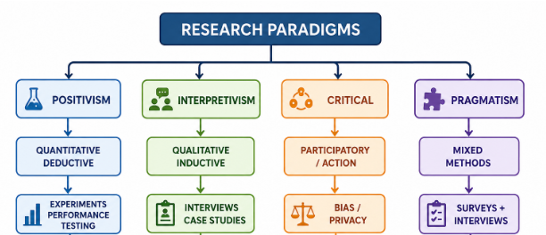
Figure: Research Paradigms

1. Positivism / Postpositivism
- Belief: Objective reality exists and can be studied through observation and measurement.
- Methodology: Quantitative, deductive, hypothesis-based, and controlled.
- IT Example: Experimentally comparing the performance of two algorithms using processing time and accuracy.

2. Social Constructivism / Interpretivism
- Belief: Reality and meaning are socially and historically constructed through human experiences.
- Methodology: Qualitative, inductive, and uses open-ended data collection.
- IT Example: Studying users’ experiences and perceptions of a software system through interviews or case studies.

3. Advocacy / Participatory / Critical Research
- Belief: Research should address power, inequality, social justice, and real-world problems.
- Methodology: Collaborative, participatory, and action-oriented.
- IT Example: Using action research to improve a system with active participation of users or studying algorithmic bias and privacy.

4. Pragmatism
- Belief: Focuses on what works to solve a specific research problem rather than following one philosophy.
- Methodology: Mixed-methods, combining quantitative and qualitative approaches.
- IT Example: Using surveys to measure system satisfaction and interviews to understand the reasons behind the results.

Influence on IT and Computer Systems Research
Paradigm | Methodology | Typical IT Research
Positivism/Postpositivism | Quantitative | Experiments, performance testing
Constructivism/Interpretivism | Qualitative | HCI, usability, user experience
Critical Research | Participatory/Action | Algorithmic bias, privacy, system improvement
Pragmatism | Mixed-methods | System adoption, evaluation

Conclusion: Research paradigms influence the research questions, methodology, data collection, analysis, and interpretation used in IT and computer systems research.

